**Student’s Declaration**

We, hereby declare that the project report titled “Book Store” submitted to the Purbanchal University, is a record of an original work done by us under the guidance of Mr. Deepak Khadka, Head of Department of Science and Technology, Kist College of Science and Technology, and this project work is submitted in the partial fulfillment of the requirements for the award of the degree of Bachelor in Information Technology in Computer Science. The results embodied in this thesis have not been submitted to any other University or Institute for the award of any degree or diploma. If we are found guilty of copying any other report or published information and showing as our original work, we understand that we shall be liable and punishable by Purbanchal University, which may include marks deduction, repeat study and re-submission of the report or any other punishment that Purbanchal University may decide.

|  |  |  |  |  |
| --- | --- | --- | --- | --- |
| S.N | NAME | Regd.No. | Symbol No. | Signature |
| 1 | Rukesh Basukala | 058-3-2-02804-2016 | 350439 |  |

**Acknowledgement**

It is our proud privilege to release the feelings of our gratitude to several persons who helped us directly or indirectly to conduct this project work.

This project would not have been possible without the essential and gracious support of Mr. Deepak Khadka, our program coordinator. His willingness to motivate us contributed tremendously to our report.

We acknowledge with thanks the kind of patronage, loving inspiration and timely guidance, which we have received from our respected teacher, Mr. Nutan Sir. We would also like to thank him for showing us some examples related to the topic of this report.

We are really grateful because we managed to complete our project within the given time with the effort and cooperation from our group members. Last but not least, we would like to express our gratitude to our friends and respondents for their support and willingness to spend some time with us and provide to us their valuable notions and suggestions.

**Table of Contents**

**Topic Page no.**

1. Background

I. Introduction 1

II. Objective of the project 2

III. Future Implementation of the project 3

IV. Introduction to the software and language used

### Sublime Text  3

2. PHP 4

3. Bootstrap 4

1. System Recommendation

I. Hardware Requirement 5

II. Software Requirement 5

1. Problem Faced 6
2. System Design

I. Algorithm 7

II. Flow Chart 8

III. E-R Diagram 9

1. Limitations 10
2. Conclusion 11
3. Bibliography 12

# 

# 1. Background

## I. Introduction

A book is both a usually portable physical object and the body of immaterial representations or intellectual object whose material signs, written or drawn lines or other two-dimensional media, the physical object contains or houses. As a physical object, a book is a stack of usually rectangular pages oriented with one side tied, sewn or otherwise fixed together and then bound to the flexible spine of a protective cover of heavier, relatively inflexible material so that, when the opened front cover has received a massy enough stack of sheets, the book can lie flat.

But along with the increase in use of technology, people nowadays prefer to purchase books online and wish it to be delivered to them as they do not have much time to go the book store or libraries and search for the book they want to buy for hours. Due to this reason the use of physical books is decreasing and same with their purchase. As a result, purchase and use of books digitally is taking over the worlds and so is the concept of Book Stores. However, people still love to read physical books and so they purchase it online.

An Book Store is a virtual store on the internet where readers can browse the catalogue and select books of interest. Readers can explore books by its title or author and also purchase different books. This program enables to setup online book store, customers to browse through the books, and a system administrator to approve and reject requests for new books and maintain list of book categories. It is the effective tool to maintain the book store system. The simple user interface used in this program is perfect even for the people who are not accustomed to the present complex technology, therefore s/he can efficiently perform her/his task of exploring and purchasing books as per their preference. All the data are stored in database and are encrypted for high security purposes so this program is highly safe and secure too.

## II. Objectives of the project

The “Book Store” is software prepared for the people who are fond of reading books but do not have enough time to go through the book store or library and money to buy a new one. The main objective of this software is to provide clean, user-friendly and multi-functional system suitable for people who love to read and wish to purchase old and new books online.

The Objectives of this project are listed below:-

* To make the system user friendly so that a normal user can access through it easily.
* To provide complete security of the data stored from all unauthorized access.
* To increase efficiency and save time and money.
* To provide easy access to the saved data inside the system.
* To make the system economical.
* To reduce manpower and manual paper works for maintaining the records
* **To provide old books (second hand books) at low cost.**
* **To connect different people who wants to buy and sell their books at best price.**

## 

## III. Future Implementation for the Project

The project that we have undertaken is a simple attempt to make the online book buying and selling process easy, so it is still lacking in some of the aspect and we will be trying to improve it by including even more features so that it will be able to overcome present limitations it is affected with.

Therefore the possible future implementations for this project are as follows:-

* Including SMS services.
* Including even more variety of books
* Including searching option
* Including filter the books list
* One can take information about future releasing book.

## IV. Introduction to software and language used

### Sublime Text

### Sublime Text is a [proprietary](https://en.wikipedia.org/wiki/Proprietary_software) [cross-platform](https://en.wikipedia.org/wiki/Cross-platform) [source code editor](https://en.wikipedia.org/wiki/Source_code_editor) with a [Python](https://en.wikipedia.org/wiki/Python_(programming_language)) [application programming interface](https://en.wikipedia.org/wiki/Application_programming_interface) (API). It natively supports many [programming languages](https://en.wikipedia.org/wiki/Programming_languages) and [markup languages](https://en.wikipedia.org/wiki/Markup_languages), and functions can be added by users with [plugins](https://en.wikipedia.org/wiki/Plugins), typically community-built and maintained under [free-software licenses](https://en.wikipedia.org/wiki/Free_software_licenses).

### PHP

PHP started out as a small open source project that evolved as more and more people found out how useful it was. Rasmus Lerdorf unleashed the first version of PHP way back in 1994.

* PHP is a recursive acronym for "PHP: Hypertext Preprocessor".
* PHP is a server side scripting language that is embedded in HTML. It is used to manage dynamic content, databases, session tracking, even build entire e-commerce sites.
* It is integrated with a number of popular databases, including MySQL, PostgreSQL, Oracle, Sybase, Informix, and Microsoft SQL Server.
* PHP is pleasingly zippy in its execution, especially when compiled as an Apache module on the Unix side. The MySQL server, once started, executes even very complex queries with huge result sets in record-setting time.
* PHP supports a large number of major protocols such as POP3, IMAP, and LDAP. PHP4 added support for Java and distributed object architectures (COM and CORBA), making n-tier development a possibility for the first time.
* PHP is forgiving: PHP language tries to be as forgiving as possible.
* PHP Syntax is C-Like.

1. **Bootstrap**

Bootstrap is a free and open-source framework for creating websites and web applications. It's the most popular HTML, CSS, and JS framework for developing responsive, mobile first projects on the web.

Bootstrap is an open source project originally created by Twitter to enable creation of responsive, mobile first web pages. Bootstrap has a standard set of classes that allow developers to quickly create applications that scale to devices of all sizes, and incorporate common components such as dialog boxes and validation.

# 2. Software Recommendation

The minimum system requirements to run the software:

* 1. Hardware Requirement**:**
* PC with Pentium II Processor (260 MHz) or latest.
* RAM of 1 GB or more.
* Color Monitor.
* Hard disk with at least 80GB of free space.

## II. Software Requirement:

* Windows Operating System ( Windows XP, Windows 7, Windows 8 or 8.1, Windows 10 or latest)
* Web Browser

# 3. Problem Faced

Programming itself is known as problem solving task. However, while developing this program we faced many obstacles, and we overcame some of the problems while trying our best to solve.

Some of the main problems we faced are as follow:

1. Designing the UI (User Interface).
2. Difficulty in extracting data from database.
3. Difficulty in linking different page.
4. Difficulty in error detection while coding.
5. Difficult to meet users’ expectations.
6. Difficulty in limiting the features.

# 4. System Design

## I. Algorithm

Step 1: START

Step 2: Home Page will be shown with Shop, about us, contact and login.

2.1. In Shop, the user can View all books available in “BOOK STORE”. But can’t buy a Book until logged in.

2.1. In About us, the user can get information about “BOOK STORE”.

Step3: In Login, The login form will be open.

Step 4: If you have already account then

4.1. Enter your Email account and password.

Else

4.2. Created and account.

Step 5: After login, Program show the home page as Add Books, My Books and Cart.

5.1. In Add Book, the user can add the book mentioning their details with price.

5.3. In My Books, the user can look towards the Books they have added in “BOOK STORE” and can update and delete Books.

5.4. In Cart, the user can look towards the Books they have requested.

5.5. In Shop, the user can see all Books and Buy (or add to cart) any Book they are interested in.

Step 6: STOP

## II. Flowchart

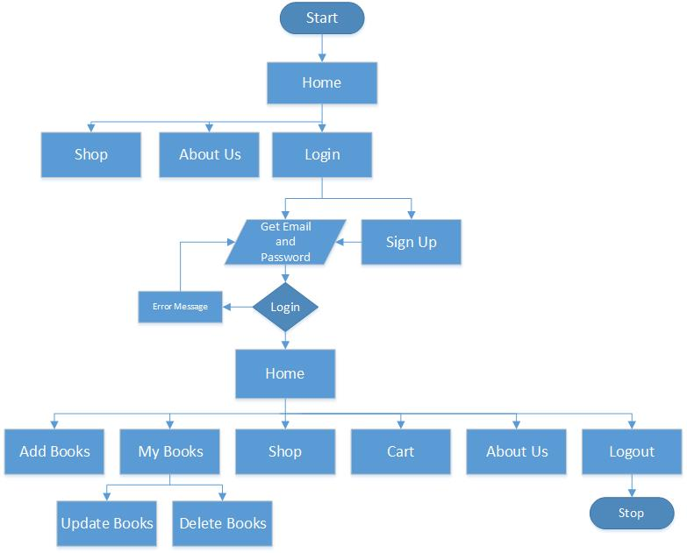

## III. E-R Diagram

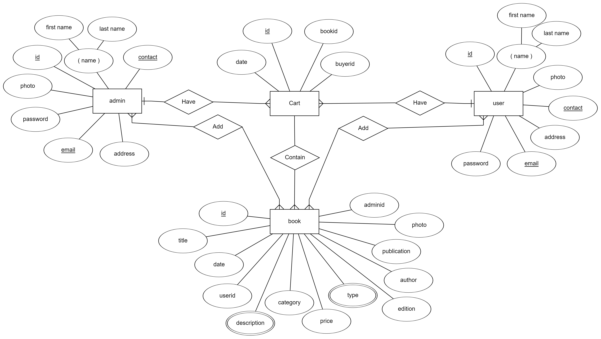

# 

# 5. LIMITATIONS

There are some limitations of this software, which are as follow:

1. There is no provision of editing password for user
2. There is no provision of editing user information
3. There is no provision of online sms service.

# 6. CONCLUSION

We were successfully able to complete this project entitled “Book Store” which is a Webpage developed using PHP. Through this system we met our objectives by simplifying information recording process, reducing data redundancy, saving time and increasing accuracy.

Also, we learn about how the online webpage works and how we have to analyze and design the system to meet users’ expectations.

However, it is not a complete online system and there are many improvements to be made such as, including online sms services, improving security more, etc.

# 7. Bibliography

* <https://www.w3schools.com/>
* [https://www.tutorialspoint.com/php /](https://www.tutorialspoint.com/php%20/)
* <https://www.w3schools.com/bootstrap4/>
* <https://stackoverflow.com/>